**Progress Report Project**

**Exams and Months**

**S.No. Exam Type Month**

1. Bi-Monthly Exam 1 (B.M-I) - July
2. Term End Exam 1 (T.E-I) - September
3. Bi-Monthly Exam 2 (B.M-II) - December
4. Tern End Exam 2 (Pre-Board) (T.E-II) - February
5. Annual Final Exam (Final Exam) - March

**Subjects for Test with marks**

|  |  |  |  |  |  |  |  |  |
| --- | --- | --- | --- | --- | --- | --- | --- | --- |
| **Subjects** | **B.M-I** | **T.E-I Theory** | **B.M-II** | **T.E-II (Pre-Board)** | **Annual** | **INA** | **Practical** | **Final Result** |
| **Punjabi A** | **20** | **65** | **20** | **65** | **65** | **10** | **-** | **Annual + INA** |
| **Punjabi A** | **20** | **65** | **20** | **65** | **65** | **10** | **-** | **Annual + INA** |
| **Hindi** | **20** | **80** | **20** | **80** | **80** | **20** | **-** | **Annual + INA** |
| **English** | **20** | **80** | **20** | **80** | **80** | **20** | **-** | **Annual + INA** |
| **Mathematics** | **20** | **80** | **20** | **80** | **80** | **20** | **-** | **Annual + INA** |
| **Science** | **20** | **80** | **20** | **80** | **80** | **20** | **-** | **Annual + INA** |
| **Social Science** | **20** | **80** | **20** | **80** | **80** | **20** | **-** | **Annual + INA** |
| **Computer Science** | **20** | **50** | **20** | **50** | **50** | **5** | **45** | **Annual + INA + Practical** |
| **Health and Physical Education** | **20** | **50** | **20** | **50** | **50** | **10** | **40** | **Annual + INA + Practical** |

**Result Declaration based on these exams**

Final Result of Each Candidate in these exams is : Punjabi A Final Result + Punjabi B Final Result + Hindi Final Result + English Final Result + Mathematic Final Result + Science Final Result + Social Science Final Result

**Computer Science and Health and Physical Education Final Result are Grade Based Result and so can be summed up in Final Marks obtained by students.**

**So, each candidate’s obtained marks are out of: 150 (For both Punjabi A and Punjabi B) + 100 (Hindi)+100 (English) + 100 (Mathematics) + 100 Science + 100 (Social Science) = 650.**

**Percentage of Marks Obtained by a candidate = Total of Marks obtained (mo) x 100 / Total Max Marks (650) = mo x 100 / 650**

**Suggest me a suitable web technology to build this project work for example HTML, CSS, JavaScript and JSON DB for entering the marks of each student for each subject using frontend user interface (UI) to get final progress report using generate reports for various exam types.**

**It seems like you're creating or working on a progress report for project exams and their corresponding months. However, your message got cut off, and I couldn't see the complete details for the final item or additional context.**

**Would you like help refining this list, formatting it for better presentation, or completing it? Just let me know how I can assist!**

**Can I upload the MS Word Document to better convey my idea?**

**Absolutely, Jagdev! Feel free to upload your MS Word document, and I'll review it to better understand your idea. From there, I can assist with formatting, organizing, or providing feedback. I'm ready whenever you are!**

**Progress Report Project.docx**

**Uploaded**

**Doc**

**Thanks for sharing your document, Jagdev! Based on its content, you're working on a progress report project involving various exams, subjects, and marks, along with calculating final results and percentages. Additionally, you're looking for suggestions to build this project using web technologies. Here's a plan you could follow:**

**Suitable Web Technologies**

**To create your progress report system, you could use:**

1. **HTML: For structuring the content of your web pages (e.g., forms, tables for marks entry and result display).**
2. **CSS: For styling the interface to make it visually appealing.**
3. **JavaScript: For adding functionality, like form validation, dynamic calculations, and interactivity.**
4. **JSON Database: To store data such as students' marks, subjects, and exam types. You can use JSON as a lightweight, easy-to-manage database.**
5. **Backend Option (Optional): If you want a more scalable approach, you can consider adding a backend server (e.g., Node.js) to handle data processing and storage more securely.**

**Project Workflow**

**Here's how you can organize your project:**

1. **Frontend Development:**
   * **Use HTML forms for entering marks.**
   * **Tables to display the results.**
   * **Buttons for generating reports.**
   * **Use CSS to create a user-friendly layout.**
2. **Logic with JavaScript:**
   * **Write functions for calculating percentages based on marks and exam types.**
   * **Use JavaScript to dynamically update results on the page.**
3. **Data Storage with JSON:**
   * **Store marks, subjects, and exam details in JSON format.**
   * **Load and update data using JavaScript.**
4. **Report Generation:**
   * **Generate downloadable or printable progress reports using JavaScript libraries like jsPDF.**
5. **Optional Backend:**
   * **Use Node.js to set up an API for secure data exchange between the frontend and backend.**

**If you'd like, I can help you with specific code snippets or guide you through any of these steps. Let me know how you'd like to proceed!**

**What are best practices for organizing this web project?**

**Organizing a web project effectively can make a huge difference in development speed, scalability, and maintainability. For your progress report system, here are some best practices:**

**1. Directory Structure**

**Create a clear and logical folder structure. For example:**

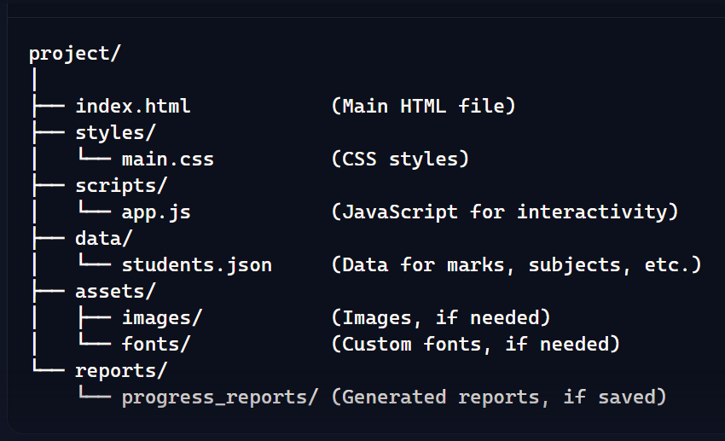

**2. Use Modular Code**

* **Break your code into smaller, reusable modules. For instance:**
  + **Write separate functions in app.js for tasks like mark validation, percentage calculation, and result generation.**
  + **Keep data operations (like reading or writing JSON) in a separate file or part of the script.**

**3. Semantic HTML**

* **Use appropriate HTML5 tags like <table> for displaying marks and results, <form> for data entry, and <header> or <footer> for layout consistency.**
* **Make it accessible with aria-labels and proper semantic tags.**

**4. Responsive Design**

* **Use CSS Flexbox or CSS Grid to create layouts that adapt to different screen sizes.**
* **Ensure your project looks good on desktop, tablet, and mobile devices.**

**5. Version Control**

* **Use Git to track changes in your project. Initialize a local Git repository and sync it with GitHub or GitLab for backup.**

**6. JSON for Data Handling**

* **Store student data in a JSON file (students.json). Example:**

**json**

**[**

**{**

**"name": "Student A",**

**"marks": {**

**"Punjabi A": {"B.M-I": 20, "T.E-I": 65, "B.M-II": 20, "T.E-II": 65, "Annual": 65, "INA": 10},**

**...**

**}**

**}**

**]**

* **Use JavaScript to read and update this data dynamically.**

**7. Use Libraries**

* **Use JavaScript libraries like:**
  + **jsPDF for creating downloadable PDF reports.**
  + **DataTables.js for enhancing the functionality of HTML tables (sorting, filtering, pagination).**

**8. Testing and Debugging**

* **Test each module independently.**
* **Use browser developer tools to debug layout issues and JavaScript errors.**

**9. Documentation**

* **Keep a README.md file explaining the purpose of the project, how to run it, and details of the structure and workflow.**

**10. Keep It Simple**

* **Avoid over-engineering. If your project is straightforward (like managing and displaying data), focus on simplicity and usability.**

**Following these practices will help you build a scalable, maintainable, and efficient progress report system. Let me know if you'd like guidance on any specific part!**

**Optional Backend**

How I can make use of Optional Backend: Use Node.js to set up an API for secure data exchange between the frontend and backend for this project.

Setting up an optional backend using Node.js for your progress report project is a great idea for ensuring secure and efficient data exchange. Here's how you can integrate it step by step:

1. Install Node.js and Initialize Your Project

* Install Node.js on your system.
* Create a new directory for your backend. Navigate to it in the terminal and run:

bash

npm init -y

This initializes a package.json file for managing dependencies.

2. Set Up Required Libraries

Install the necessary libraries using npm:

bash

npm install express body-parser cors

* Express: To create the backend server.
* Body-parser: To parse incoming request data in JSON format.
* CORS: To allow secure data exchange between your frontend and backend.

3. Write the Backend Code

Create a file named server.js and set up your API:

javascript

const express = require('express');

const bodyParser = require('body-parser');

const cors = require('cors');

const app = express();

app.use(bodyParser.json());

app.use(cors());

// Mock JSON database (can replace with a proper DB like MongoDB)

let studentData = [];

// Endpoint to add student data

app.post('/add-student', (req, res) => {

const student = req.body;

studentData.push(student);

res.send({ message: 'Student data added successfully!' });

});

// Endpoint to get all student data

app.get('/get-students', (req, res) => {

res.send(studentData);

});

// Start the server

app.listen(3000, () => {

console.log('Server is running on port 3000');

});

4. Connect the Frontend to Backend

From your frontend, make HTTP requests to your backend using Axios or the built-in fetch API in JavaScript. Example:

POST Request to Add Data:

javascript

fetch('http://localhost:3000/add-student', {

method: 'POST',

headers: { 'Content-Type': 'application/json' },

body: JSON.stringify({

name: 'Student A',

marks: {

"Punjabi A": {"B.M-I": 20, "T.E-I": 65, "Annual": 65, "INA": 10},

// Add other subjects

}

})

}).then(response => response.json())

.then(data => console.log(data))

.catch(error => console.error(error));

GET Request to Fetch Data:

javascript

fetch('http://localhost:3000/get-students')

.then(response => response.json())

.then(data => console.log(data))

.catch(error => console.error(error));

5. Secure Your API

* Validate incoming data on the server side before saving it to your database.
* Use environment variables to store sensitive information, like database credentials.

6. Deploy Your Backend

Once your backend is ready, you can deploy it using platforms like Heroku or Railway. This will make your API accessible to anyone on the internet.

7. Optional Database Integration

You can extend this setup to use a database like MongoDB for better scalability and data management. Here's what you'd need:

* Install MongoDB locally or use a cloud solution like MongoDB Atlas.
* Replace the mock JSON database in server.js with MongoDB operations using the Mongoose library.

Example Project Workflow

With this setup, your frontend will handle the user interface for entering marks and generating reports, while your backend securely stores and retrieves data. This separation also makes your project scalable and easier to manage.

Let me know if you'd like help with implementing any of these steps!